FAQs
Service Request – General
Q1. How can I access the Service Request section?
A. The Service Request section can be accessed via: Left Menu > Mutual Funds > Service Request.
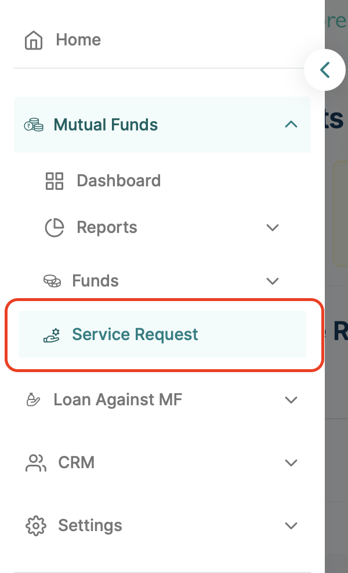
Q2. How can I raise a Service Request for my clients?
A. On the main landing page of the Service Request section, click the ‘Add Service Request’ button located in the top right corner. A list of available service requests will be displayed. You can select any of them to initiate a request.
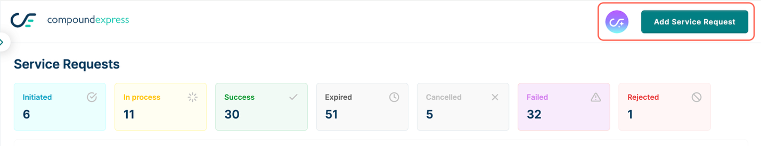
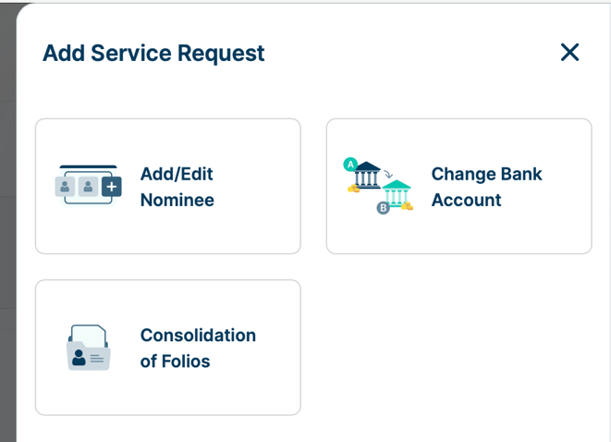
The process of raising a service request is as follows:
Request Initiation by the MFD:
- Select the client by searching for their name in the search bar.
- Choose the relevant service request and provide the required details.
- Send the request to the investor for approval.
- The investor will receive an email (with a Review button) and an SMS (containing a link) to approve the request from compoundexpress.
Investor Authorization Process:
- The investor can access the request details by clicking the Review button in the email or the link provided in the SMS.
- Upon clicking the Review button or link, the request approval page will open, displaying the request details.
- The investor can either:
  - Approve the request by clicking the Confirm button, or
  - Reject the request by clicking the Reject button.
- Depending on the type of service request, the investor may be required to provide additional details.
- Approve the request using the OTP received from MFCentral on the folio-registered mobile number.
- Once successfully authorized, the request may take up to 3 business days to be processed.
- The investor will receive a confirmation via email and SMS from compoundexpress upon successful submission of the service request. The MFD will also receive a confirmation email from compoundexpress once the request is approved by the investor.
- Upon successful processing of the request at MFCentral, the investor will also receive communication directly from the respective AMCs.
Q3. What is the TAT (Turnaround Time) for completion of a service request?
- It may take up to 3 business days for a request to be processed.
Q4. How can I track the status of a service request raised?
A. Yes, MFDs can track the status of a service request from the landing page of the Service Request section by following these steps:
- Navigate to the Service Request section landing page.
- Under the Recent Service Requests section, previously raised requests will be listed.
- Click on the three dots icon under the Actions column and select View Details from the dropdown.
- In the right-side hover panel, check the Updates section for the status and details of the service request.
Q5. For how long is the Service Request history available?
A. Currently, the Service Request history is available for the last 3 months only.

Service Request – Consolidation of Folios
Q1. What is Consolidation of Folios and why is it needed?
- Consolidation of Folios is the process of merging multiple folios held with the same mutual fund house into a single folio. This is often needed when, due to multiple account opening requests, separate folios are created unintentionally. Consolidating your folios helps streamline your investments, making it easier to track, manage, and transact – all from a single folio.
Q2. What is a target folio?
- A target folio is the folio that will be retained after the consolidation of your folios.
Q3. What is a source folio?
- Source folios are the folios that will be merged into the target folio after the successful execution of the consolidation request.
Q4. What type of folios are eligible for Consolidation of Folios?
- Currently, only folios with a single mode of holding and tax status as 'Individual' are eligible for the Consolidation of Folios request.
Q5. What are the conditions/criteria for submitting a request for Consolidation of Folios?
- Only those folios within a particular AMC can be consolidated that have matching email ID, mobile number, bank account, holding type, tax status, and nominee details. For KFin, there is an additional criterion that source folios should not have any active SIPs ongoing.
Q6. What will happen to the source folios? Can the investor reuse them for future transactions?
- No. Once the source folios are consolidated, they become ineligible for transactions or holding units and will not be available for selection during the transaction journey.
Q7. Can I request consolidation at the scheme level?
- No. Consolidation of folios is done for all holdings (schemes) in the source folios.

Service Request – Add / Edit Nominees
Q1. How many nominees can I add?
A. You can add up to a maximum of 3 nominees to a particular folio.
Q2. Who can I add as a nominee?
A. You can add your blood relatives or spouse as nominees. If you wish to add someone else, please select the ‘Others’ option and proceed.
Q3. Can I add a minor as a nominee?
A. Yes. However, if you add a minor as a nominee, it is mandatory to provide the details of the nominee’s guardian.
Q4. What type of folios are eligible for an Add/Edit Nominee request?
A. Currently, only folios with a single mode of holding and tax status as 'Individual' are eligible for the Add/Edit nominee service request.
Q5. Is it mandatory to provide details like Date of Birth or Address of each nominee?
A. Yes. Due to recent regulatory changes, this information is mandatory. If the nominee is a minor, the guardian’s details are also required.
Q6. Can I select multiple folios for adding/updating nominee details?
A. Yes. An MFD can select multiple folios in a single request to update nominee details, provided the selected folios have the same registered Email ID and Mobile Number.
Q7. Does a nominee need to be KYC compliant?
A. No, KYC compliance is not mandatory at the time of adding or updating a nominee. However, investors are required to provide ID details (such as PAN, Aadhaar, Driving License, or Passport) as part of the KYC-related information. The nominee must be KYC compliant at the time of making a claim.

Service Request – Change Bank Account
Q1. What is Change Bank Account and why is it needed?
A. It is the process of updating the registered bank account in an investor's folio to ensure seamless processing of redemption amounts, lump sum purchases, SIP payments, and more. Changing the bank account linked to your mutual fund investments can be essential when switching banks, closing an account, or managing finances more effectively.
Q2. A folio has multiple bank accounts registered under it. Which bank account will be updated if a "Change Bank Account" request is processed?
A. The Change Bank Account request will update only the primary/folio-registered bank account details.
Q3. What details and documents are required from the investor while raising a Change Bank Account request?
A. The investor must provide the following inputs:
- Bank account details of the new bank account to be added.
- Scanned copy of a cheque from the existing folio-registered bank account (JPEG/JPG image or PDF).
- Scanned copy of a cheque from the new bank account (JPEG/JPG image or PDF).
- Investor declaration: A clear image or PDF capturing the signature and name of the investor.
Q4. What type of folios are eligible for a Change Bank Account?
A. Currently, only folios with single mode of holding and tax status marked as ‘Individual’ are eligible for the Change Bank Account request.
Q5. What are the conditions/criteria for submitting a Change Bank Account request?
A. Only those folios that have matching bank account number, IFSC, email ID, mobile number, holding type, and tax status will be grouped and submitted in a single request.
Q6. Are there any restrictions on initiating a Change Bank Account request?
A. Yes, currently there is a limit of INR 10 lakh at the PAN level. A Change Bank Account request cannot be raised for investors with current holdings exceeding INR 10 lakh (at the PAN level).

Service Request – Add Bank Account
Q1. What is the Add Bank Account service and why is it needed?
A. The Add Bank Account service allows an investor to register an additional bank account in their folio. This ensures seamless processing of redemption amounts, lump sum purchases, SIP payments, and other transactions through any of the registered bank accounts. An investor can register up to 5 bank accounts in a folio, with one designated as the default account.
Q2. Can I change my default or primary bank account in the folio using the Add Bank Account service?
A. No. The default or primary bank account in the folio cannot be changed using the Add Bank Account service. To update your primary bank account details, you need to submit a request through the Change Bank Account service.
Q3. What details and documents are required from the investor while raising an Add Bank Account request?
A. The investor must provide the following inputs:
- Bank account details of the new bank account to be added.
- Scanned copy of a cheque from the folio-registered primary bank account (in JPEG/JPG or PDF format).
- Scanned copy of a cheque from the new bank account (in JPEG/JPG or PDF format).
Q4. What type of folios are eligible for the Add Bank Account?
A. Currently, only folios with a single mode of holding and tax status marked as ‘Individual’ are eligible for the Add Bank Account request.
Q5. What are the conditions/criteria for submitting an Add Bank Account request?
A. Only those folios with matching details – including bank account number, IFSC, email ID, mobile number, holding type, and tax status – will be grouped and submitted under a single request.
Q6. Are there any restrictions on initiating an Add Bank Account request?
A. Yes. Currently, there is a limit of INR 10 lakh at the PAN level. An Add Bank Account request cannot be raised if the investor’s total holdings exceed INR 10 lakh (at the PAN level).

Service Request – Update Contact Details
Q1. What is the Update Contact Details service and why is it needed?
A. The Update Contact Details service allows investors to update or modify their registered email address and mobile number in their folio. This ensures that investors continue to receive timely transaction alerts, regulatory communications, OTPs, and other important updates from RTAs and the respective AMCs.
Q2. If an investor wants to update the mobile number registered in the folio, how will compoundexpress validate the authenticity of the request?
A. To authorize the request, validation will be done by triggering two OTPs:
- In the case of updating the mobile number, the first OTP will be sent to the folio-registered email ID, followed by a second OTP to the new mobile number.
- In the case of updating the email ID, the first OTP will be sent to the folio-registered mobile number, followed by a second OTP to the new email ID.
Q3. What type of folios are eligible for the Update Contact Details service?
A. Currently, only folios that meet the following criteria are eligible:
- Both email ID and mobile number are registered.
- Mode of holding is ‘Single.’
- Tax status is marked as ‘Individual.’
Q4. What are the conditions/criteria for submitting an Update Contact request?
A. Only those folios with matching details – email ID, mobile number, holding type, and tax status – will be grouped and submitted under a single request.
Q5. Why does the investor need to authenticate the new email ID/mobile number using OTP?
A. Investment-related information is highly sensitive and should not reach unintended recipients. To ensure the security of this information, RTAs need to verify the investor’s new email ID/mobile number through OTP authentication. OTP verification helps RTAs ensure that the details are captured correctly and enables the investor to receive all relevant information accurately and on time.

Q6. The investor has multiple folios registered with the same email ID and mobile number combination. Can the investor select only a few of them to update the email ID or mobile number?
A. No. Currently, this facility is not available on compoundexpress. Any update request will result in a change of the email ID/mobile number across all linked folios.
Q7. The investor is trying to update the email ID, but the existing mobile number is not accessible or working, and vice versa. How will the investor be able to authenticate?
A. In such cases, the investor must first update the mobile number and then place a request to update the email ID. If both contact details are not available, the investor will need to follow the physical, form-based process for updating the details.
Q8. If the investor raises a request to update the mobile number, will the request authorization link be sent to the old mobile number?
A. No. In the Update Contact Details request, the authorization link is sent only to the contact detail that is not being updated.
- If the mobile number is being updated, the request authorization link will be sent only to the registered email ID.
- If the email ID is being updated, the request authorization link will be sent only to the registered mobile number.

